Student Notebook

Final Project: The Science of Art Conservation

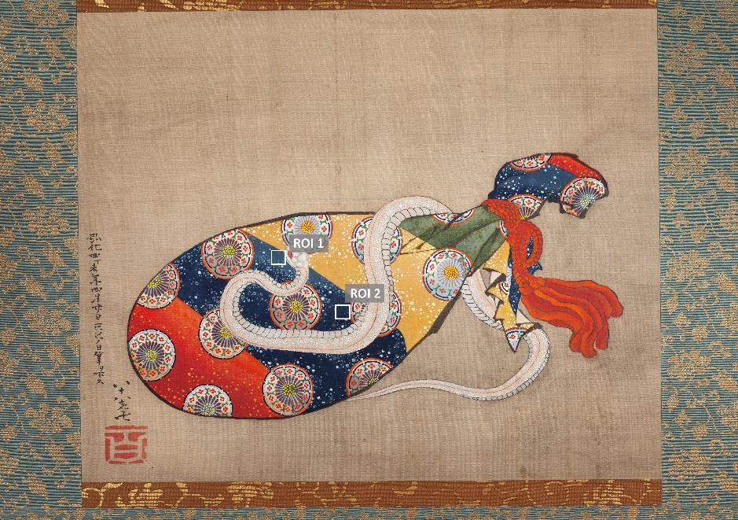

Painting at the Smithsonian Museum of Asian Art, by the artist Hokusai

**BACKGROUND:** To preserve and better understand artworks, conservation scientists use a variety of scientific techniques—including examining paintings using infrared light, ultraviolet, and sometimes even x-rays—to understand the nature and origin of the materials employed.

**PROJECT TASK:** For this case study, you will investigate two paintings to help a museum curator prepare an exhibition. You will try to determine the pigments used, the geographic origin and the century of the paintings, and you will provide some explanations about some of the techniques you would use as an imaging scientist. You will have available a [Table of Select Pigments](https://docs.google.com/document/d/12tWtxQ2-CibGcFYxlEbWjwgogqQr0MFKGtHnW1s0N7Y/edit?usp=sharing), [Technical Information](https://drive.google.com/file/d/1glxaK8Rq7QUYG0l5UlcYezOxpmYehu-j/view?usp=sharing), and the Spectrum Tool to investigate two paintings.

# **Science of Art Conservation**

## Watch a video on conservation and conservation science and how spectra are used in analyzing paintings.

Describe 2 techniques that allow conservation scientists to determine what pigments were used in a painting.

|  |
| --- |

What can conservation scientists learn about a painting from knowing what pigments were used in it?

|  |
| --- |

## **Note:** Follow guidance from your teacher on whether to choose to investigate either the **Chokha painting** or **Hokusai painting,** or **both**.

# **Chokha Painting**

## **Part 1: Observe the Artwork**

1. Describe what you see. What do you notice or find yourself wondering about the painting?

|  |
| --- |

1. What details in the painting do you think could be helpful to you in trying to pinpoint the region and time period this painting comes from?

|  |
| --- |

## 

## **Part 2: Paint Colors and Spectra**

Match the “mystery spectra” to the relevant regions of interest in the painting. **Draw a line** from each spectrum to the corresponding region of interest on the painting.

| Mystery Pigment 1 Spectrum | Yellow |
| --- | --- |
| Mystery Pigment 2 Spectrum | White |
| Mystery Pigment 3 Spectrum | Red |
| Mystery Pigment 4 Spectrum | Blue |

# **Chokha Pigments**

## Part 1: Spectra

Complete the Table by writing the pigment for each Region of Interest. Identify the ROIs where you have confidence in the pigment identification.

| Region of Interest | Pigment | Confidence |
| --- | --- | --- |
| ROI W1 |  |  |
| ROI B1 |  |  |
| ROI Y1 |  |  |

# 

## 

## Part 2: UV Imaging

View video describing UV imaging techniques.

## Part 3: UV-induced Luminescence

Complete the Table by identifying a ROI with UVL. Use the Pigment Data Table to identify the pigment and note whether you are confident in the identification.

| Region of Interest with UVL | Pigment | Confidence |
| --- | --- | --- |
|  |  |  |

# 

## Part 4: Time Period and Region

For Regions of Interest in the painting where you feel confident of your pigment identifications, use the Pigment Data Table to identify the time period and geographic region where the pigments were commonly used.

| ROI | Pigment | Period of utilization | geographic region |
| --- | --- | --- | --- |
|  |  |  |  |
|  |  |  |  |
|  |  |  |  |

What constraints can you place regarding when and where this painting was created?

|  |
| --- |

# **Hokusai Painting**

1. Describe what you see. What do you notice or find yourself wondering about the painting?

|  |
| --- |

1. What details in the painting do you think could be helpful to you in trying to pinpoint the region and time period this painting comes from?

|  |
| --- |

# **Hokusai Pigments**

## Part 1: Spectra

Complete the Table by writing the pigment for each Region of Interest. Identify the ROIs where you have confidence in the pigment identification.

| Region of Interest | Pigment | Confidence |
| --- | --- | --- |
| ROI B1 |  |  |
| ROI B2 |  |  |
| ROI W1 |  |  |
| ROI Y1 |  |  |

# 

## Part 2: Time Period and Region

For Regions of Interest in the painting where you feel confident of your pigment identifications, use the Pigment Data Table to identify the time period and geographic region where the pigments were commonly used.

| ROI | Pigment | Period of utilization | geographic region |
| --- | --- | --- | --- |
|  |  |  |  |
|  |  |  |  |
|  |  |  |  |
|  |  |  |  |

What constraints can you place regarding when and where this painting was created?

|  |
| --- |

# 

# **Bonus: Hokusai IR Imaging**

## Part 1: IR Imaging

View video describing IR imaging techniques.

## Part 2: Blue Spectra

Identify 1-2 similarities and 1-2 differences between the spectra at the visible part of the spectrum and the IR part of the spectrum.

|  | Similarities between B1 & B2 | Differences between B1 & B2 |
| --- | --- | --- |
| Visible only  (Under “Normalize?” click the radio button next to “Visible”) |  |  |
| Infrared only |  |  |

At what wavelength range do you observe the greatest difference in brightness between the B1 and B2 regions of the painting?

|  |
| --- |

Imagine you wanted to know the composition of other blue regions of interest in the painting, but you don't have access to a spectrometer to measure spectra for the other regions. Conservators have the option of photographing the entire image using different filters, for example, red, green, or blue, or even infrared filters. Based on the differences in the spectra of the two blue pigments you observed, which filter would be most helpful for distinguishing which of the two blue pigments were used in other parts of the painting?

|  |
| --- |

## 

## Part 3: Identify Blue

What pigment do you think is used at ROI B3?

|  |
| --- |

# 

What clues did you use from the filtered images to identify the pigment at ROI B3?

|  |
| --- |

# **Design Museum Display**

**PROJECT TASK:** Design a display for a museum exhibit highlighting the use of light, color, and spectra in analyzing artworks. Choose one of the works of art featured in this project to display in an exhibit. Develop a display that tells the story of the hidden details a visitor might not see from looking at the piece. Your display should include:

* At least two regions of interest within your chosen painting
* At least one spectrum or comparison image taken with the techniques described in this activity
* A caption with a description describing how art conservationists might use the data presented.