**Spectrum Lab**

**Module 1: Light**

# **Light in Different Professions**

**Your interests.** Of the different professions featured in the slideshow, which are you most curious about? What questions do you have about how that field uses light?

|  |
| --- |

# **Color Filters**

Consider the 3 intersecting colored circles shown on the screen

**Part 1: Predictions**

**Do NOT look through any of the colored gels yet!-**

**a. Predict** what you will see when you look through the **red-colored gel** at the 3 intersecting colored circles on screen. In the diagram below, color in (or write the name of the color) each of the 7 sections to represent how you think the onscreen image will look through the red gel:

| **1** |  |
| --- | --- |
| **2** |  |
| **3** |  |
| **4** |  |
| **5** |  |
| **6** |  |
| **7** |  |

**b. Share your reasoning.** How did you determine which parts of the circles would be visible and what colors the different parts of the circles would appear?

|  |
| --- |

**Part 2: Investigation-**

**You can NOW look through the gels.**

**c. What did you actually see** when you looked through the red gel? How did it compare with your prediction?

|  |
| --- |

**d. Describe what you think** is happening, given the colors you saw through the red gel:

|  |
| --- |

**e. Discuss your ideas** with your partner. What ideas did your partner add that seemed helpful?

|  |
| --- |

# 

# **Photons & Color**

**Launch** the Color Vision “Single Bulb” simulation from Physics Education Technology (PhET).

## **Part 1: Instructions**

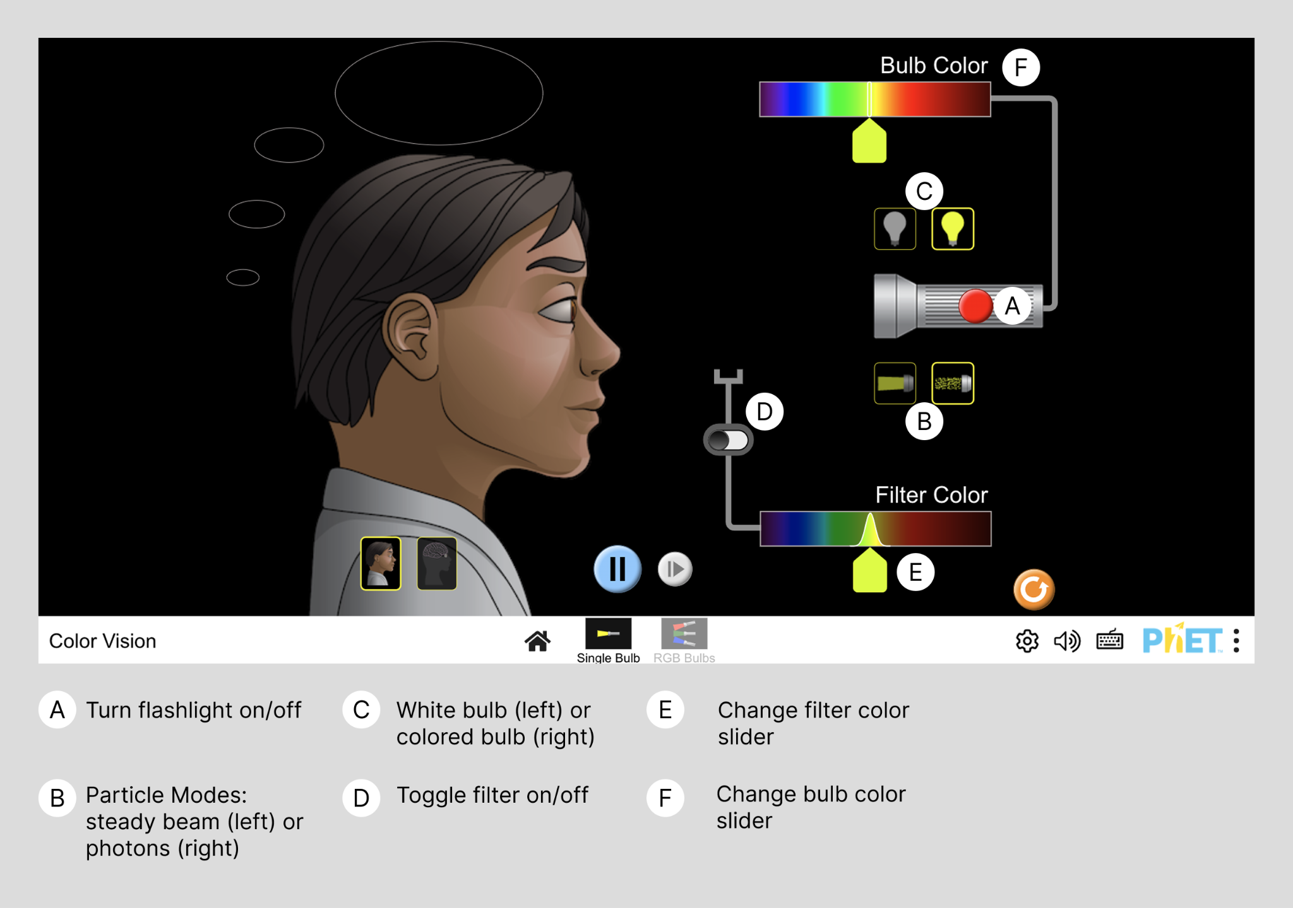

Choose **Single Bulb** and do the following:

1. Turn on the flashlight (red button). (A)

Free-explore the interactive for a couple of minutes. Try different modes and turn on different combinations of bulb color and filter color.

Investigate what makes up **WHITE** light and what colored filters do.

1. Choose the particle mode for the light (underneath the flashlight, with photons instead of a steady beam). (B)
2. Choose a white bulb. (C)
3. Turn on a colored filter (there is a toggle in front of the mouth). (D)
4. Choose a red color for the filter. (E)

Investigate how colored filters behave with single-colored light sources.

1. Choose the light bulb that opens Bulb Color. (C)
2. Switch Bulb Color to a blue light. What happens to the light particles? (F)
3. Change the light to red, similar to your filter color. What happens to the light particles? (F)
4. Change the light bulb to the white one. What happens to the light particles of different colors? (C)

## 

## **Part 2: Reflection Questions**

**Describe** what makes up white light.

|  |
| --- |

**Describe** what a red filter does.

|  |
| --- |

**Describe** what happens if you put a RED filter in front of a GREEN light source.

|  |
| --- |



# **Color Mixing**



## **Part 1: Instructions**

1. Switch to the **RGB Bulbs** simulation to explore how light colors mix.
2. Experiment with the RGB (red, green, and blue) lights in different amounts to make different colors. Try turning on two at a time, or three at a time but at different levels. Then try to make the following colors.

For each color, make a note in the table below for each R, G and B whether the bulb was OFF (**O**), or on at low (**L**), medium (**M**), or high (**H**) power. (You don’t have to be very precise here).

**What combinations of RGB lights make:**

| Yellow | R |  | G |  | B |  |
| --- | --- | --- | --- | --- | --- | --- |
| Magenta (bright reddish purple) | R |  | G |  | B |  |
| Cyan (bright greenish blue) | R |  | G |  | B |  |
| Orange | R |  | G |  | B |  |
| White | R |  | G |  | B |  |

**Fun facts:**

Most computer screens are made up of tiny light bulbs (called light-emitting diodes, or LEDs) that emit red, green or blue light.

If you have ever done any web design, you might be familiar with the hexadecimal color system. Hexadecimal codes specify to the computer the amounts of red, green, and blue light to display on each pixel on the screen.

## **Part 2: Reflection**

Imagine you are looking at a source that is emitting yellow light. There are at least two possible combinations of one or more photon colors that would cause your eye to observe the source as yellow in color.

**Identify** those two combinations here.

Review the Photons and Color section if you’re feeling stuck.

|  |
| --- |
|  |



# **Behaviors of Light**



**NOTE:** Most objects interact with light in more than one way, and they often interact differently with different wavelengths of light. For example, tree leaves absorb red and blue photons and reflect green photons.

## 

## **Part 1: Slideshow**

After viewing the slideshow, apply what you learned to the diagram below. Circle or highlight the letters of the objects that are associated with the light phenomena listed. (Some may have more than one answer.)

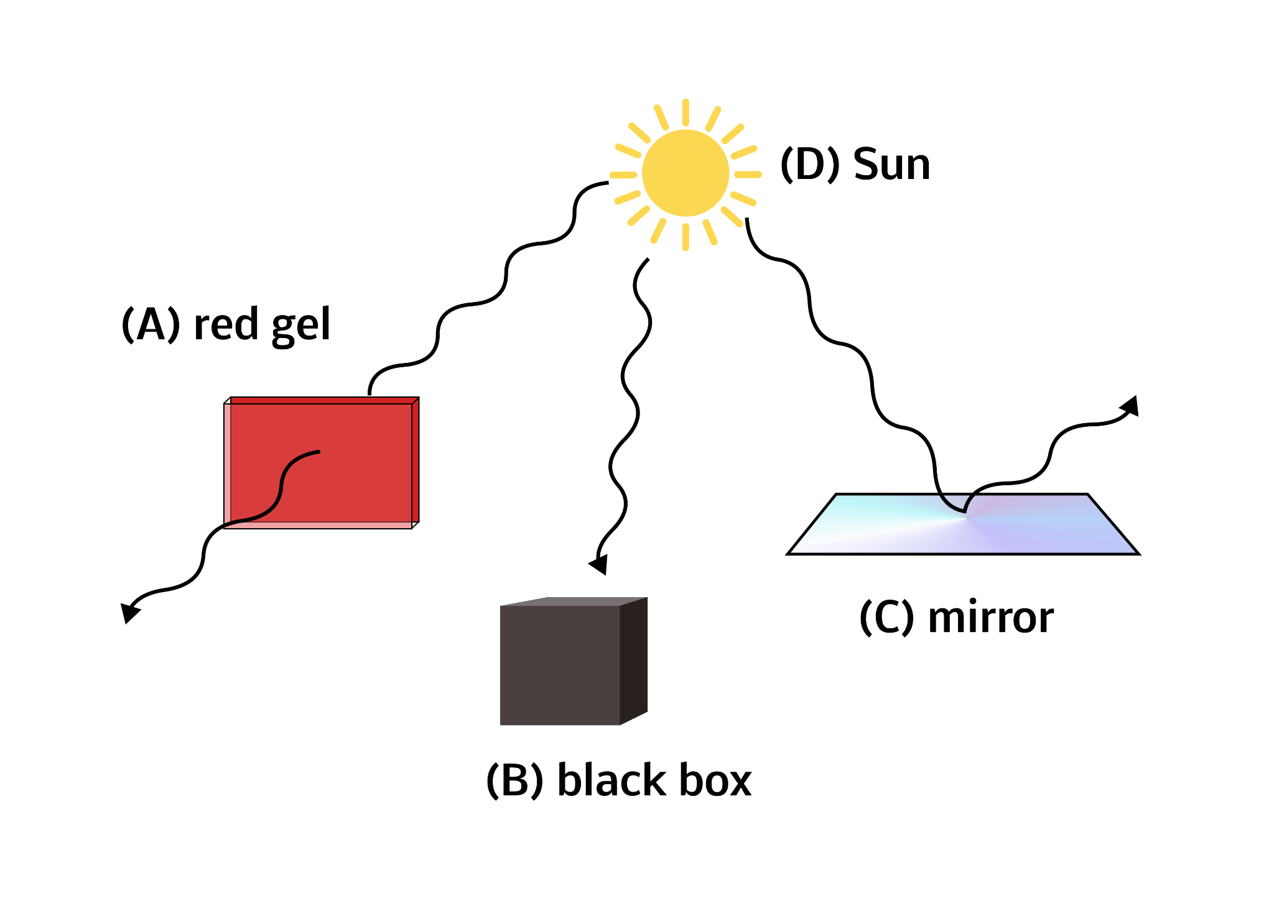

| 1. Emission | **A** | **B** | **C** | **D** |
| --- | --- | --- | --- | --- |
| 2. Reflection | **A** | **B** | **C** | **D** |
| 3. Absorption | **A** | **B** | **C** | **D** |
| 4. Transmission | **A** | **B** | **C** | **D** |

# 

**Part 2: Recap**

Let’s return to the three overlapping colored circles you viewed at the beginning of class. Use all four light behaviors (emission, reflection, transmission, absorption) to describe what is happening when you look at them through the red gel. You may discuss your ideas with a partner, as a class, or in small groups, as directed by your teacher.

|  |
| --- |