**Spectrum Lab**

**Final Project: Lighting Design for a Saltwater Aquarium**

Create and light a saltwater reef aquarium that is healthy, and looks great too. For this project, you’ll first learn about how a lighting designer at the Smithsonian American Art Museum uses light to make exhibits pop! Then you can begin your own adventure using light to design a unique habitat for fish, coral and plants. You’ll explore the spectra of a Regal Angelfish and then dive into the project by investigating a variety of plants, fish and coral that live in saltwater aquaria. You’ll choose a few to live in your tank. Based on what you’ve learned in this unit, you’ll decide how to light the tank so all of its inhabitants thrive.

## Explore Lighting Design

First, watch the Museum Lighting Design video to find out how lighting can be used to make artworks “look as good as they can.”

**Reflection Spectra and Colors**

Explore more about the reflective spectra of different parts of a Regal Angelfish.

Choose any of the mystery spectra and see if you can guess which color it represents. Fill in the chart below.

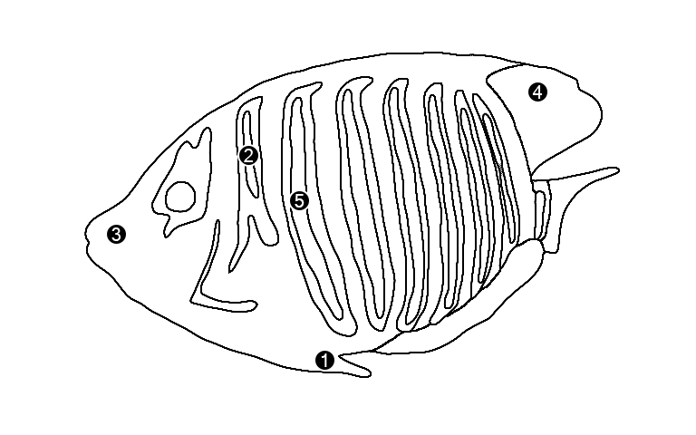

|  | **Color we see based on reflection spectrum** | **Region on fish that corresponds to each spectrum** |
| --- | --- | --- |
| Spectrum A |  |  |
| Spectrum B |  |  |
| Spectrum C |  |  |

Now that you’ve practiced interpreting reflection spectra, you are ready to start thinking about lighting your fish tank to optimize the health of the plants and make your fish look great.

## Plant Reflection Spectra

## Answer the following questions about the reflection spectrum of the Shaving Brush Plant

1. Within the visible part of the spectrum, at what wavelength does the plant reflect the most amount of light? Is this in line with your expectation? Why or why not?

|  |
| --- |

1. Chlorophyll is the most important pigment in most green plants, and it absorbs sunlight to make food for the plant through photosynthesis. Based on the shaving brush plant’s reflection spectrum, what color photons do you think are the ones that the plant needs to perform photosynthesis to keep it healthy?

|  |
| --- |

Now that you’ve practiced interpreting reflection spectra, you are ready to start thinking about lighting your fish tank to optimize the health of the plants and make your fish look great.

## Your Saltwater Aquarium

## Part 1: Choosing plants (algae) and animals (fish and coral) to live in your tank

For this task, you should select **at least 2 fish**, **2 plants** and **1 type of coral** from the **attached charts**. Think about the needs of the entire system. Which animals and plants can live together? Do all of your plants and corals have the same lighting needs? If not, you’ll have to find a way to keep them all healthy. Which color combinations of plants and animals will look the best in the tank?

1. Use this chart to keep track of the needs of your organisms.

| **Name** of fish, plant or coral | **Color(s)** of organism | **Light intensity needed** (low, moderate, high, any) | **Other needs**  (hiding places, etc.) |
| --- | --- | --- | --- |
|  |  |  |  |
|  |  |  |  |
|  |  |  |  |
|  |  |  |  |
|  |  |  |  |
|  |  |  |  |

1. Explain why you chose these plants and animals:

|  |
| --- |

## 

## Part 2: Lighting the needs of your inhabitants

Lighting not only enhances the appearance of your tank, it also helps keep the inhabitants healthy. When deciding on which lights to use for your tank, you should try to recreate the conditions in which your aquarium plants and animals would live naturally.

1. First look at the information charts for coral and algae you picked for your tank. What are the best colors and intensities of light to keep each of them healthy? Look at the reflection spectrum for each organism - **what colors are reflected? Absorbed?**

| **Name** of plant or coral | **Color(s)** of organism | **Pigment** (if present) | **Reflected color** of pigment | **Wavelengths** reflected by pigment, if present (in nm) | **Wavelengths** absorbed by pigment, if present (in nm) |
| --- | --- | --- | --- | --- | --- |
|  |  |  |  |  |  |
|  |  |  |  |  |  |
|  |  |  |  |  |  |
|  |  |  |  |  |  |

1. Now it’s time to add your fish into the mix.

| **Name** of fish | **Reflected color(s**) of fish | **Wavelength(s)** of reflected by fish (in nm) |
| --- | --- | --- |
|  |  |  |
|  |  |  |
|  |  |  |
|  |  |  |

## Lighting your aquarium

**Part 1: Choose your light colors**

You can choose from 3 LED light colors to light your tank: red, blue and green. You will need to decide the intensity (light level) of each color (low, moderate or high). Each combination will give your tank a different look. For example, a tank with equal parts red, green and blue will appear white (remember the simulation from Day 1) but by adjusting the percent of each color, your tank’s light can enhance the colors of your fish, and keep your plants and coral healthy. Remember what you learned from the land plants about reflected light.

| For example, to get a tank with a teal hue, you could use high green and low blue | /Users/ssunbury/Desktop/FISHTANK PROJECT/FISHtank photos/mixes/100% green 20% blue.jpg |
| --- | --- |
| Or, for a tank which appears orange, you could use medium red and low green | /Users/ssunbury/Desktop/FISHTANK PROJECT/FISHtank photos/mixes/50% red 10% green.jpg |

1. Use the **PheT simulation** (RGB bulbs) to see lots of color combinations.

### [Color Vision](https://phet.colorado.edu/sims/html/color-vision/latest/color-vision_en.html)

1. Color of my tank:

|  |
| --- |

1. Take a screenshot from the simulation of the color combination you’d like to use for your tank and paste it here:

|  |
| --- |

1. Colors mixed to create my tank color – describe the level of each color (high, medium or low):

| Red |  |
| --- | --- |
| Green |  |
| Blue |  |

In terms of the health of your organisms and your aesthetic goals, explain why you chose this color combination:

|  |
| --- |

## 

**Part 2: Draw Your Tank’s Spectrum**

**Return to the Spectrum Tool** to view sample spectra showing various percentages of red, green and blue light.

<https://waps.cfa.harvard.edu/microobservatory/spectrum/fishtank.html>

With these as guides, use the drawing tool to create the overall spectra of an empty tank with your lighting design. Take a screenshot and paste it here:

|  |
| --- |

## Inhabitants Under Your Lights

1. Now imagine adding the fish, coral and plants to the tank. If you need help thinking about this, use this stage lighting simulation.

### <https://www.physicsclassroom.com/Physics-Interactives/Light-and-Color/Stage-Lighting/Stage-Lighting-Interactive>

1. What colors do you think your plants and coral appear with your lighting scheme?

| **Name** of plant or coral | **Actual color(s)** of organism | **Color organism appears** under my lights |
| --- | --- | --- |
|  |  |  |
|  |  |  |
|  |  |  |
|  |  |  |

Color the fish you chose as they would appear with your lighting scheme (or type in the colors that correspond to the numbered sections of the fish in the boxes below):

|  | | | | | | | | | |  | | | | | | | | | |
| --- | --- | --- | --- | --- | --- | --- | --- | --- | --- | --- | --- | --- | --- | --- | --- | --- | --- | --- | --- |
|  | | | | | | | | | |  | | | | | | | | | |
|  |  |  |  |  | | | | | | | | | | | |  |  |  |  |
| **1** |  | | | **2** |  | | | **3** |  | | | **4** |  | | | **5** |  | | |

## 

## Put it all together

Using all the data you’ve collected in Parts I-IV, write a paragraph that describes the set-up of your tank including what creatures you’ve chosen to live in the tank, what lighting scheme you have chosen for the tank and why you made these choices.

In this paragraph you should:

1. Identify the inhabitants you’ve chosen to live in the tank and the optimal lighting scheme (the tank’s color) you’ve chosen for the well-being of these plants and animals and for your visual enjoyment. (**your claim**)
2. Review the data you gathered above in Sections I-IV. Include here the most relevant data (from the Project Data Charts, the PheT and Stage Lighting simulations, or the Spectrum Tool) that support your claim. (**your evidence**)
3. Using what you have learned about light and color throughout this Spectrum Lab, explain *why* you chose each type of plant and animal and *why* your lighting scheme works to meet the needs of the tank’s creatures and allows them to look great. You should be able to justify how the data supports your claim. For example, how do the colors you chose support the well-being of your tank’s inhabitants; and how does the appearance of the inhabitants under your lighting scheme meet your aesthetic goals for the tank? (**your reasoning**)!

|  |
| --- |

## 